# John Bell

# 12/14/2034

# John.bell3@snhu.edu

# CS 255 System Design Document

## UML Diagrams

### UML Use Case Diagram

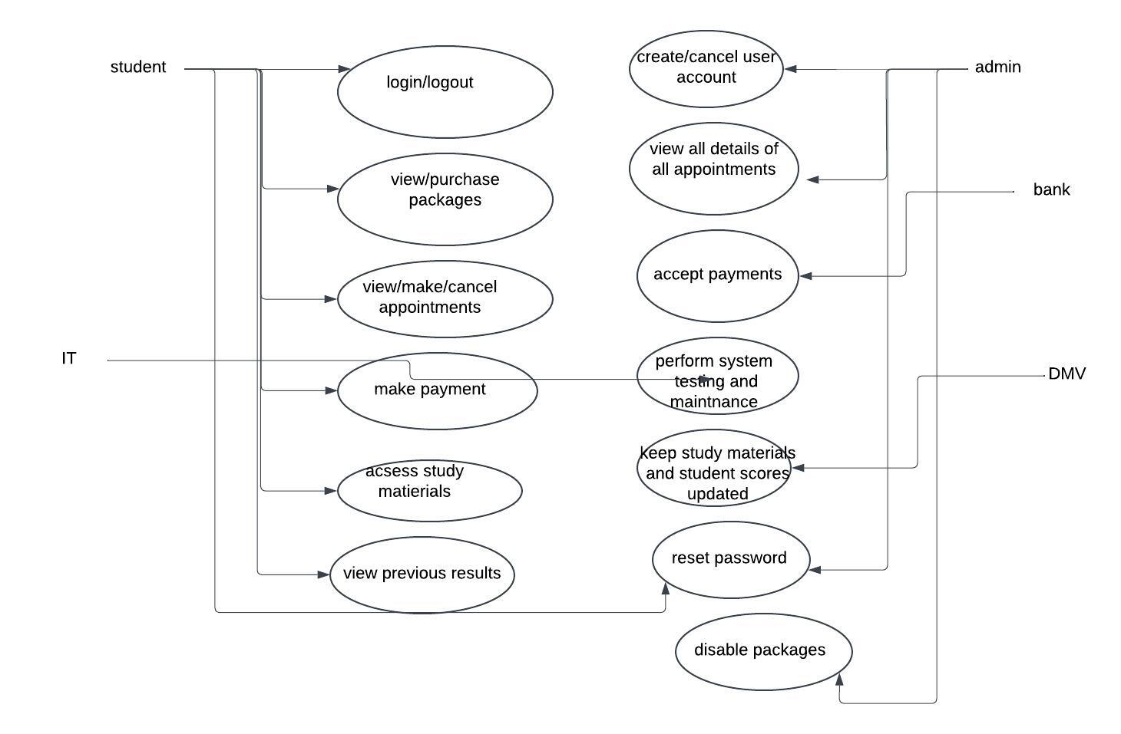

### UML Activity Diagrams

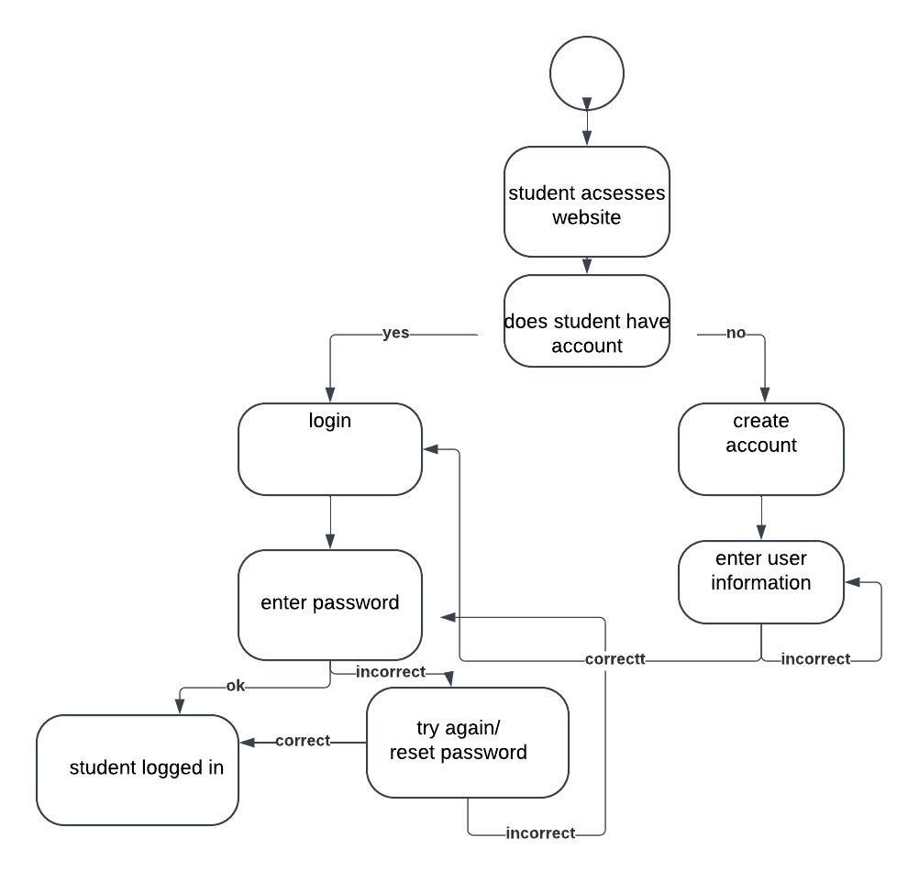

### UML Sequence Diagram

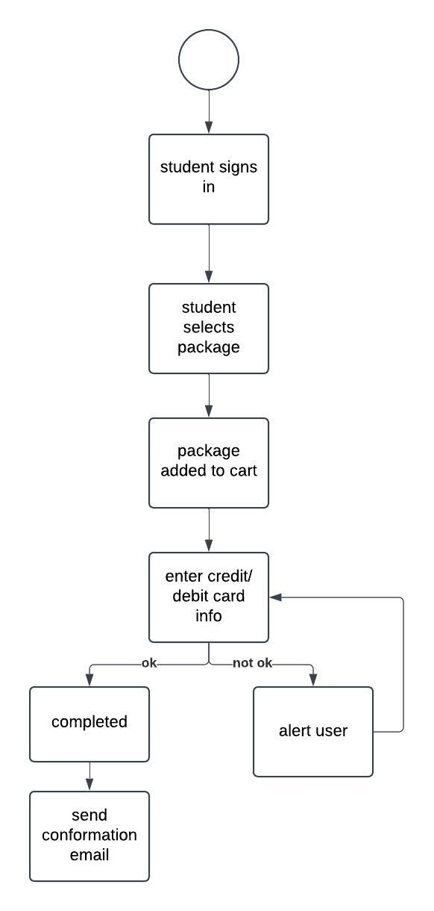

### UML Class Diagram

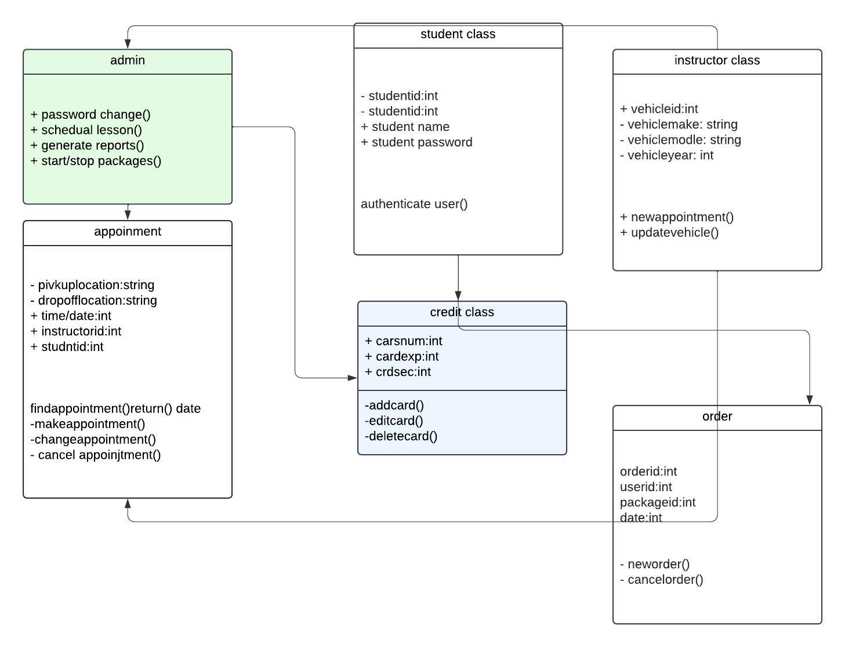

## Technical Requirements

*Hardware requirements*

*Server*

*Connection to internet*

*Firewall*

*Local database for stored site data and student info*

*Computer*

*Software requirements*

*Web server*

*User protection*

*Firewall*

*System Backup*

*Web browser*